**international communications**

**30-day media report – Research article**

**Original paper:** Targeting SOD1 via RNAi with PEGylated graphene oxide nanoparticles in platinum-resistant ovarian cancer

**Journal:** Cancer Gene Therapy

**Authors:** Attila Szénási, Enakshi Sivasudhan, Hong Du, Peizhuo Zhang, Jie Huang, Zhijun Zhang, Sonia Rocha & Mu Wang

**Date Published:** 15 August 2023

**DOI:** <https://www.nature.com/articles/s41417-023-00659-2>

**Title of press release:** Potential target for reversing drug resistance in ovarian cancer identified

**Date Published:** 6 September 2023

**URL:** <https://www.xjtlu.edu.cn/en/news/2023/09/potential-target-for-reversing-drug-resistance-in-ovarian-cancer-identified>

**Total number of unique readers of the media outlets that picked up the article per month:**

13,907,898

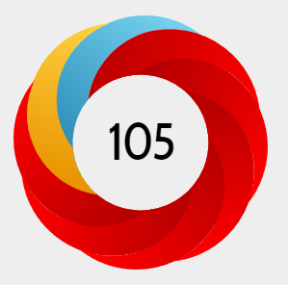**Altmetric score**

**In the top 1.5% of all research outputs scored by Altmetric.**

The Altmetric Attention Score for a research output provides an indicator of the amount of attention that it has received. The score is derived from an automated algorithm, and represents a weighted count of the amount of attention we've picked up for a research output.

**Number of media outlets that picked up the media release (excluding Chinese outlets):**

25

**Languages the article has been translated into (not including Chinese):**

Spanish, German

**Number of media outlets that picked up the media release by country (not including China)**

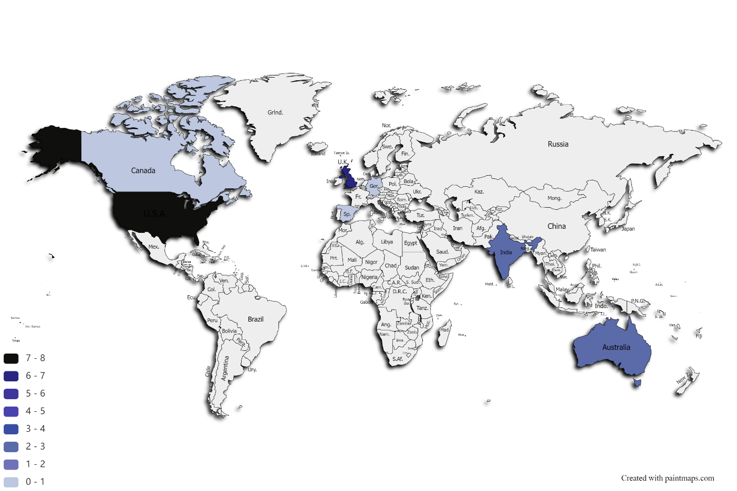

Thanks for your support and we look forward to working with you again!

The International Communications Team